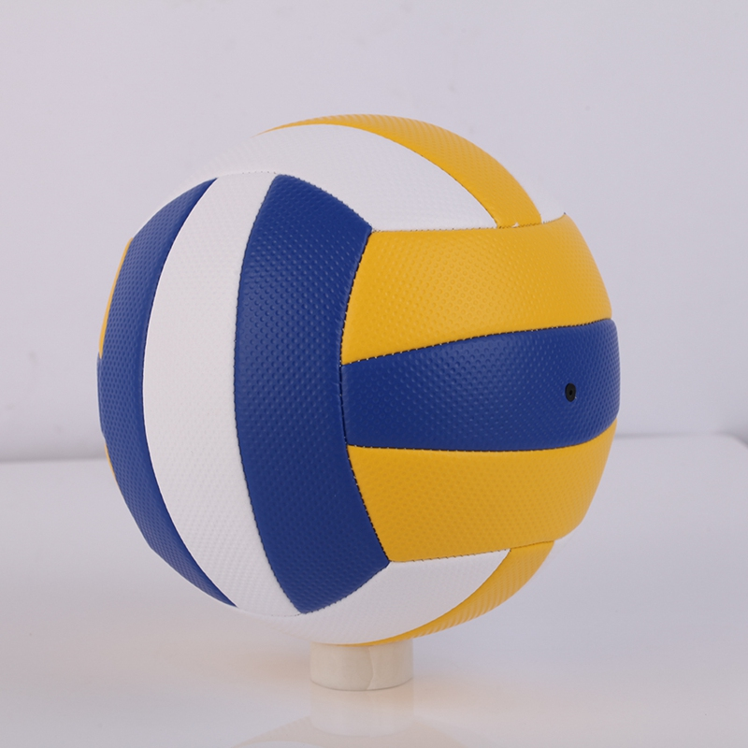

Volleyball Beach Ball smash ball volley ball idea ball training

Rs. 799

* Volleyball Beach Ball smash ball volley ball idea ball training Good Quality Durable Item Made In Pakistan Random Colors And Design
* Volleyball Beach Ball smash ball volley ball idea ball training.
* Good Quality
* Durable Item
* Made In Pakistan
* Colors And Design